KNOWLEDGE INSTITUTE OF TECHNOLOGY

(AN AUTONOMOUS INSTITUTION)
Approved by AICTE, New Delhi and Affiliated to Anna University, Chennai
Kakapalayam (PO), Salem - 637 504.



RECORD NOTEBOOK
Sss++-+

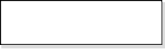
REG.NO
Certified that this is the bonafide record of work done by Selvan/Selvi………………………………………. of the………. Semester ………………………………………………………. Branch during the year ……………… in the BE23CB551 – Fundamentals of IT Service Management Laboratory.

Staff-In charge Head of the Department

Submitted for the University Practical Examination on ……………………………….

Internal Examiner External Examiner

INDEX

S.No. | Date | Name of the Exercise | Marks | Sign
1
2
3
4
5
6
7
8

AVERAGE:

EX NO: 1 DATE: | User Interface and Navigation

AIM :

To develop an automated script that logs into a instance using Selenium and extracts the list of modules displayed in the Application Navigator (left sidebar menu).

ALGORITHM :

1. Start WebDriver: Launch a browser session using Selenium.

2. Navigate to Login Page: Open the ServiceNow login URL.

3. Perform Login: Enter valid credentials and submit the login form.

4. Wait for Dashboard: Wait for the Application Navigator to load completely.

5. Extract Modules: Scrape the titles of available modules in the Application Navigator.

6. Display/Store Output: Print or save the extracted module names.

7. Close Browser: Gracefully close the browser session.

PROCESS :

1. Install required packages: selenium, webdriver-manager.

2. Write a Python script using Selenium WebDriver.

3. Use the login URL of the ServiceNow instance.

4. Use appropriate HTML element selectors (IDs, classes, XPath) to:

Input username and password

Click the login button

Wait for the navigator pane

Extract text from module elements

5. Handle dynamic loading with WebDriverWait.

6. Output results to console or file.

CODE :

from selenium import webdriver
from selenium.webdriver.common.by import By
from selenium.webdriver.common.keys import Keys
from selenium.webdriver.support.ui import WebDriverWait
from selenium.webdriver.support import expected_conditions as EC

# Initialize WebDriver
driver = webdriver.Chrome() # or webdriver.Firefox()

# Navigate to ServiceNow login page
driver.get("https://dev21190.service-now.com/")

# Input credentials
username = driver.find_element(By.ID, "user_name")
password = driver.find_element(By.ID, "user_password")

username.send_keys("your_username")
password.send_keys("your_password")
password.send_keys(Keys.RETURN)

# Wait for the Application Navigator to load
WebDriverWait(driver, 10).until( EC.presence_of_element_located((By.CSS_SELECTOR, ".navpage"))
)

# Retrieve the list of available modules
modules = driver.find_elements(By.CSS_SELECTOR, ".navpage .nav-item")

# Print the module names
for module in modules:
print(module.text)

# Close the browser
driver.quit()

OUTPUT :

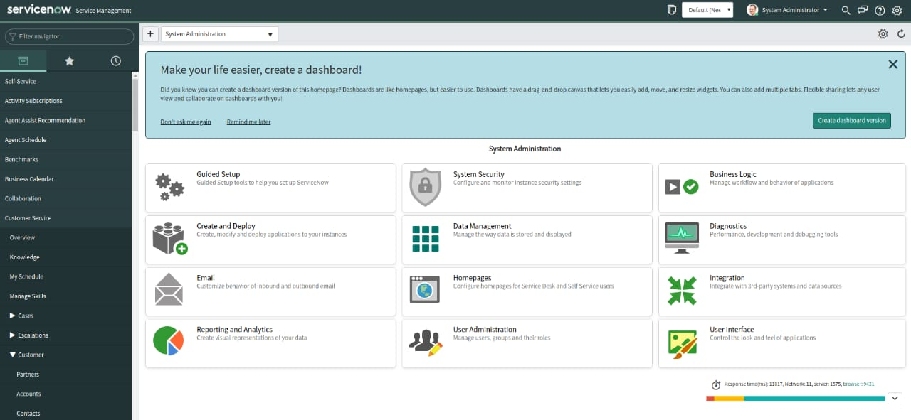
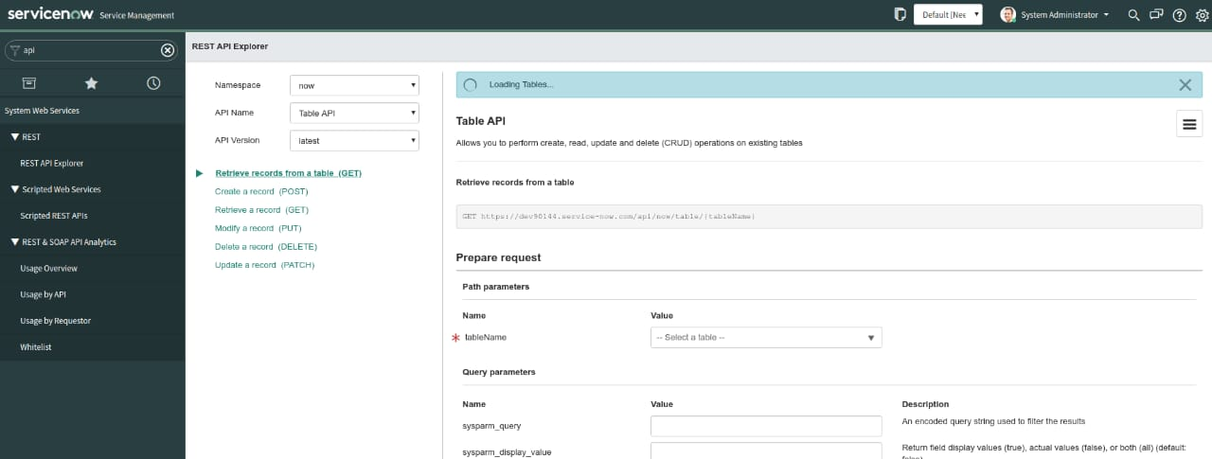

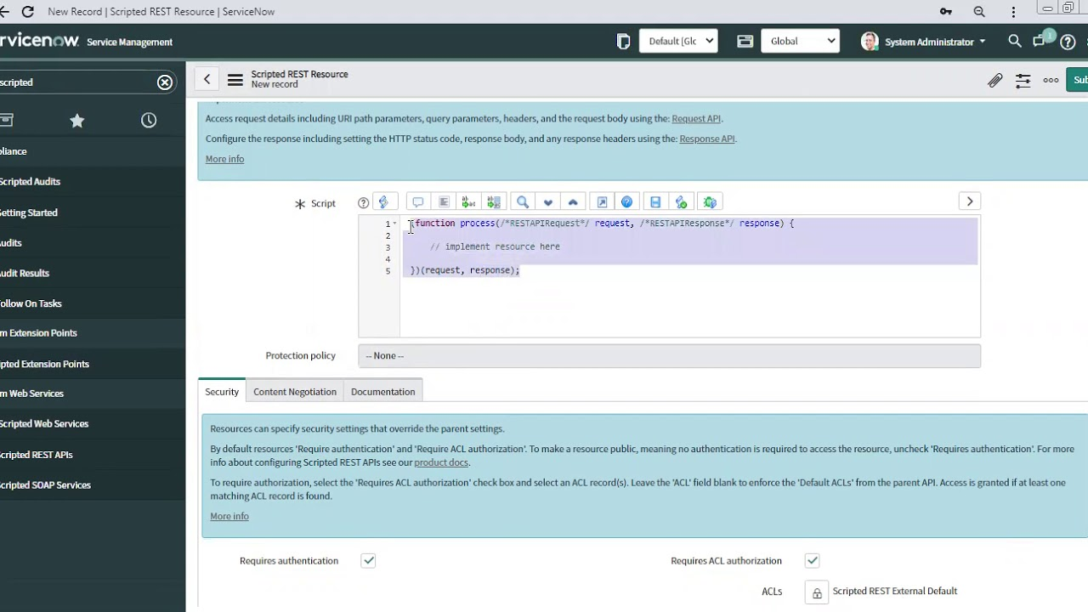

RESULT:

The program successfully logs into the ServiceNow
EX NO: 2 DATE: | Users and Roles

Aim:

To implement a solution where the visibility of specific modules in the Application Navigator is dynamically controlled based on the currently logged-in user's role.

Algorithm:

1. Login to the ServiceNow instance as a user.

2. Identify user roles through the user’s profile or session data.

3. Access the Application Navigator (left sidebar).

4. Filter modules based on the roles assigned to the user.

5. Display only the modules that the user has permission to view.

6. Output the visible modules.

Process:

1. Set up role-based access in ServiceNow:
- Assign roles to modules via the Application Menu and Module records in ServiceNow.
- Use the Roles field in each module record to control visibility.
2. Prepare test user accounts with different roles (e.g., admin, itil, catalog_user).
3. Create an automated script using Selenium to:
- Log in with a user.

- Load the Application Navigator.
- Scrape and print the visible modules.
4. Compare results for users with different roles to confirm role-based visibility is functioning.

Code :

from selenium import webdriver
from selenium.webdriver.common.by import By
from selenium.webdriver.support.ui import WebDriverWait
from selenium.webdriver.support import expected_conditions as EC
from selenium.webdriver.chrome.service import Service
from webdriver_manager.chrome import ChromeDriverManager

def get_visible_modules(username, password):
url = "https://yourinstance.service-now.com/"

driver = webdriver.Chrome(service=Service(ChromeDriverManager().install()))
driver.get(url)

# Login
WebDriverWait(driver, 10).until(
EC.presence_of_element_located((By.ID, "user_name"))
).send_keys(username)
driver.find_element(By.ID, "user_password").send_keys(password)
driver.find_element(By.ID, "sysverb_login").click()

# Switch to navigator frame
WebDriverWait(driver, 15).until(
EC.frame_to_be_available_and_switch_to_it((By.ID, "gsft_nav"))
)

# Get visible modules
modules = WebDriverWait(driver, 10).until(
EC.presence_of_all_elements_located((By.CSS_SELECTOR, ".nav_page_container .nav_item_label"))
)

print(f"\nModules visible to user '{username}':")
for mod in modules:
print("-", mod.text.strip())

driver.quit()

# Test with different users (replace with real usernames/passwords)
get_visible_modules("admin_user", "admin_password")
get_visible_modules("itil_user", "itil_password")
get_visible_modules("catalog_user", "catalog_password")

OUTPUT :

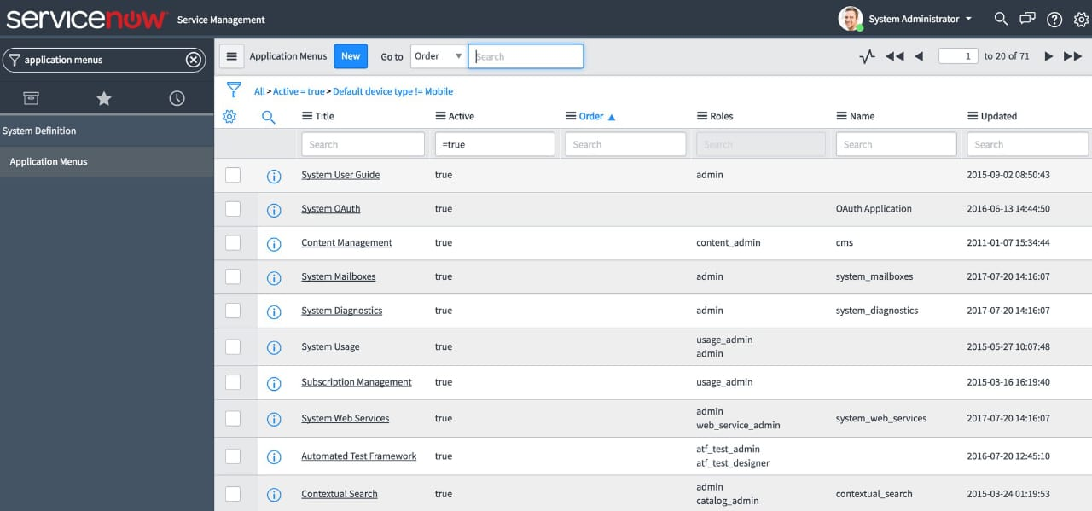

Result :

The program successfully logs into the ServiceNow

EX NO: 3 DATE: | User Access Control

AIM :

To create a script that filters the activity stream of a record to display only comments made by the assigned user.

Algorithm:

1. Identify the target record (e.g., an incident).

2. Retrieve the assigned_to user of that record.

3. Access the sys_journal_field table which stores activity stream entries.

4. Query entries where:

- element_id matches the record's sys_id.

- name matches the target table (e.g., incident).

- element is comments.

- sys_created_by matches the assigned user.

5. Display or process the filtered comments.

Process:

1. Use a ServiceNow background script or Script Include to run the query.

2. Retrieve the assigned user from the target record.

3. Use a GlideRecord query on sys_journal_field to filter comments.

4. Loop through results and output the comments.

5. This can be used in:

- Background scripts

- Script Includes

- UI actions

- Scheduled jobs

Code :

// Replace with actual record sys_id
var recordSysId = 'your_record_sys_id';
var tableName = 'incident';

// Get the assigned user
var record = new GlideRecord(tableName);
if (record.get(recordSysId)) {
var assignedUser = record.assigned_to;

if (assignedUser) {
gs.print('Comments by Assigned User (' + assignedUser.getDisplayValue() + '):');

// Query the journal fields (comments)
var commentsGR = new GlideRecord('sys_journal_field');
commentsGR.addQuery('element_id', recordSysId);
commentsGR.addQuery('element', 'comments');
commentsGR.addQuery('name', tableName);
commentsGR.addQuery('sys_created_by', assignedUser.getDisplayValue());
commentsGR.orderBy('sys_created_on');
commentsGR.query();

while (commentsGR.next()) {
gs.print('- ' + commentsGR.value);
}
} else {
gs.print('No assigned user for the record.');
}
} else {
gs.print('Record not found.');
}

OUTPUT :

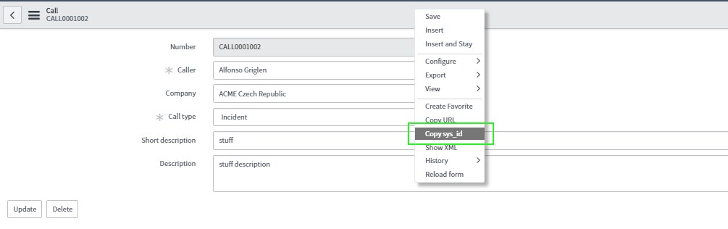
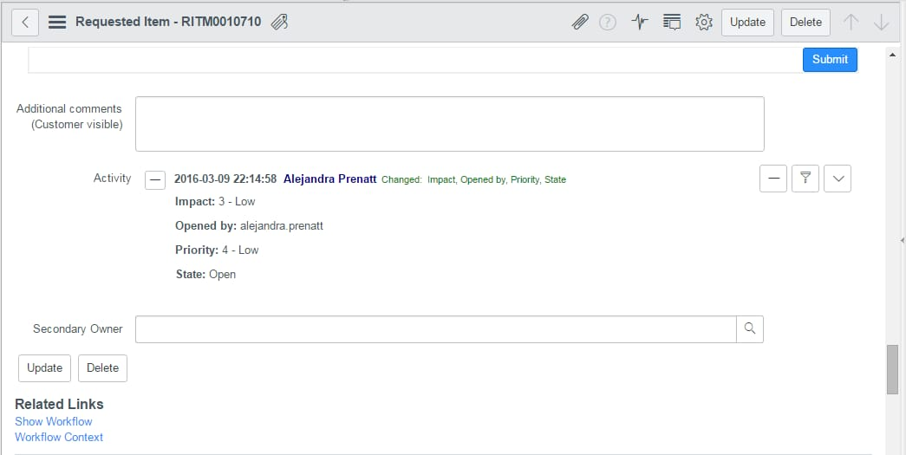

RESULT :

The script successfully filters and displays only the comments made by the assigned user in the activity stream of a given ServiceNow record

EX NO: 4 DATE: | Designing Catalogue Items

AIM :

To create a catalog item named "Laptop Request", allowing users to select a laptop model, choose optional accessories, and provide a justification for the request.

Algorithm:

1. Navigate to the Service Catalog > Maintain Items.

2. Create a new catalog item titled Laptop Request.

3. Add variables for:

- Laptop model (drop-down).

- Accessories (checkboxes).

- Justification (multi-line text).

4. Save and publish the item.

5. Test by submitting a request and verifying captured data.

Process:

- Go to: Service Catalog > Maintain Items.
2. Click "New", enter:
Name: Laptop Request
Catalog: Service Catalog
Category: Hardware (or your choice)
3. Add Variables:
Laptop Model:
Type: Single Line Choice
Name: laptop_model
Question: Select Laptop Model
Choices: Dell Latitude, HP EliteBook, MacBook Pro
Accessories:
Type: Checkbox
Question: Include Accessories
Name: accessories
Justification:
Type: Multi Line Text
Name: justification
Question: Justification for Laptop Request
4. Save and Publish the catalog item.
5. Test by impersonating a user and submitting a request via the Service Catalog.

CODE :

// Type: onChange
// Variable Name: laptop_model

function onChange(control, oldValue, newValue, isLoading) {
if (isLoading || newValue == '') {
return;
}

if (newValue == 'MacBook Pro') {
g_form.setMandatory('justification', true);
g_form.showFieldMsg('justification', 'Justification is required for MacBook Pro.', 'info');
} else {
g_form.setMandatory('justification', false);
}
}

OUTPUT :
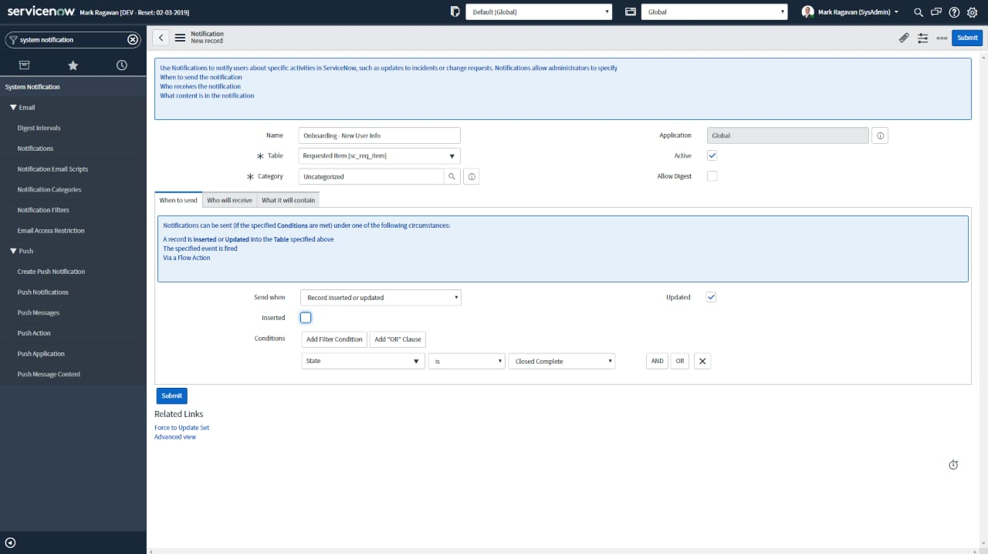

esult:

The catalog item is successfully created
EX NO: 5  DATE: | Client Scripts

AIM :

To write a client script that sets the default value of the "Priority" field to "Low" when a form is loaded in given platform.

Algorithm :

- Trigger the script when the form is loaded.
- Access the "Priority" field on the form using g_form.
- Set its value to "Low" using the setValue() method.

Process :

• Navigate to System Definition > Client Scripts in ServiceNow.
• Click New to create a new client script.
• Fill in the form:
- Name: Set Priority to Low
- Table: Choose the table (e.g., Incident)
- Type: onLoad
• Paste the script into the Script field.

CODE :

function onLoad() {
// Set the Priority field to "Low" (value = 4)
g_form.setValue('priority', '4');
}

Note: In ServiceNow, Priority field values are typically:
- 1 - Critical
- 2 - High
- 3 - Moderate
- 4 - Low
- 5 - Planning

OUTPUT :

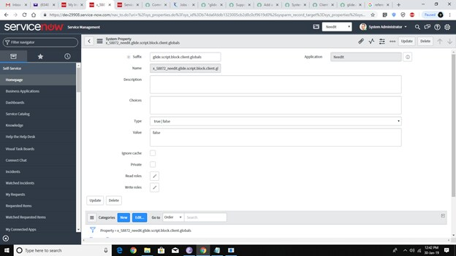

RESULT :

The Client scripts are successfully completed

EX NO: 6  DATE: | Flow Designer

AIM :

To automate an approval process for high-priority incidents using Flow Designer

Algorithm :

• Trigger the flow when a new Incident is created or updated.
• Check if the Priority is High.
• If High, create an Approval for the Manager.
• After Manager approval, create an Approval for the Director.
• Once both are approved, proceed with further actions (e.g., notify, assign).

Process :

• Navigate to: Flow Designer > Create New Flow
• Name: High Priority Incident Approval Flow
• Trigger:
- Table: Incident
- Trigger condition: When record is created or updated
- Condition: Priority is High (1)

OUTPUT :
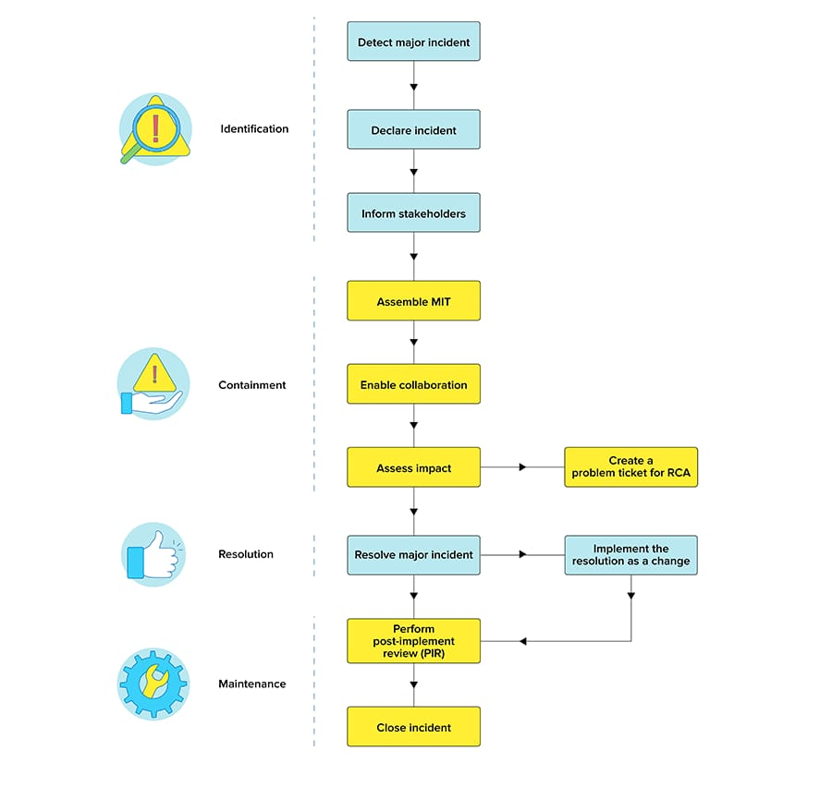

RESULT :

The Approval process was successfully completed

EX NO: 7  DATE: | Designing Business Rules

AIM :

To create a Business Rule that sends an email notification to the Assigned To user whenever a new Incident is assigned to them.

Algorithm :

- Trigger Condition: Check if the Incident has been assigned to a user.
- Action: Send an email notification to the Assigned To user.
- Ensure that the notification includes details such as Incident Number,
Description, and Assignment Group.

Process :

- Navigate to: System Definition > Business Rules
- Click on: New to create a new business rule.
- Fill out the form as follows:
- Name: Send Email Notification on Incident Assignment
- Table: Incident
- Active: True
- When: After (The rule runs after the Incident record is saved, so the Assigned To field will already be populated.)
- Condition: Check if the Assigned To field has been populated.
- Set the condition to check if the Assigned To field is not empty.
- Example: Assigned To IS NOT EMPTY
- Script: Use the script to send the email after the assignment.

CODE :

(function executeRule(current, previous /*null when async*/) {
// Ensure the Assigned To field is populated
if (current.assigned_to) {
// Prepare email notification
var mail = new GlideEmailOutbound();
// Set the recipient (Assigned To user)
mail.setTo(current.assigned_to.email);

/ Set the subject of the email
mail.setSubject("New Incident Assigned: " + current.number);
// Set the body of the email with details about the Incident
var emailBody = "Hello " + current.assigned_to.name + ",\n\n";
emailBody += "A new Incident has been assigned to you:\n";
emailBody += "Incident Number: " + current.number + "\n";
emailBody += "Short Description: " + current.short_description + "\n";
emailBody += "Assignment Group: " + current.assignment_group.getDisplayValue() + "\n\n";
emailBody += "Please review the incident and take appropriate action.";
mail.setBody(emailBody);
// Send the email
mail.send();
}
})(current, previous);

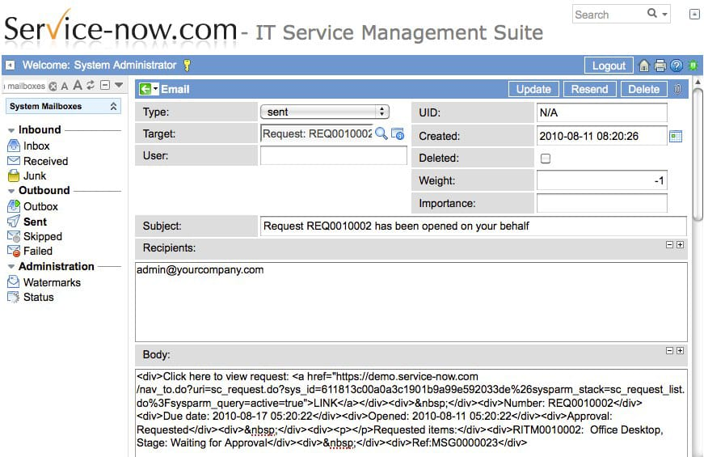
Output :

RESULT :

The process was successfully completed
EX NO: 8  DATE: | Designing the Dashboard

AIM :

To design a dashboard that provides insights into the Change Management process, focusing change requests, approval workflows, and the impact of changes on the environment.

Algorithm :

• Identify Key Metrics:
- Total number of Change Requests.
- Number of Change Requests by state (e.g., Open, In Progress, Closed).
- Number of Approvals by state (e.g., Pending, Approved, Rejected).
- Impact on the environment (e.g., how many changes caused Downtime or Service Disruptions).
• Visualize Data:
- Use Reports in ServiceNow to pull data from the Change Request table and Change Request Approval table.
- Use Widgets (bar charts, pie charts, tables, etc.) to display these metrics on the dashboard.
• Design the Dashboard:
- Create widgets for each of the identified metrics.
- Ensure the dashboard is interactive with filters (e.g., by date range, change type, environment).
• Performance: Ensure the dashboard is optimized for performance, avoiding long query times.

Process :
- Create the Reports:
  - Go to Reports > Create New in ServiceNow.
  - Create multiple reports based on the Change Request table and Change Request Approval table.
- Create the Dashboard:
  - Navigate to Performance Analytics > Dashboards and click on New to create a new dashboard.
  - Add widgets that display the following reports:
    - Change Request Status Overview (Bar chart or Pie chart)
    - Approval Workflow Status (Bar chart or Pie chart)
    - Change Impact on Environment (Pie chart, table, or bar chart)
- Add Filters:
  - Add filters to the dashboard to allow users to drill down by Change Type, Priority, Environment, Date Range, etc.
- Add KPIs and Performance Indicators:
  - Key Performance Indicators (KPIs) like:
    - Average Time to Approve Changes
    - Number of Changes Causing Downtime
    - Percentage of Changes with Delays
CODE :

// Sample Script for a report on Change Requests by state
var gr = new GlideRecord('change_request');
gr.addAggregate('COUNT');
gr.groupBy('state');
gr.query();
var result = [];
while (gr.next()) {
result.push({
state: gr.getDisplayValue('state'),
count: gr.getAggregate('COUNT')
});
}
return result;
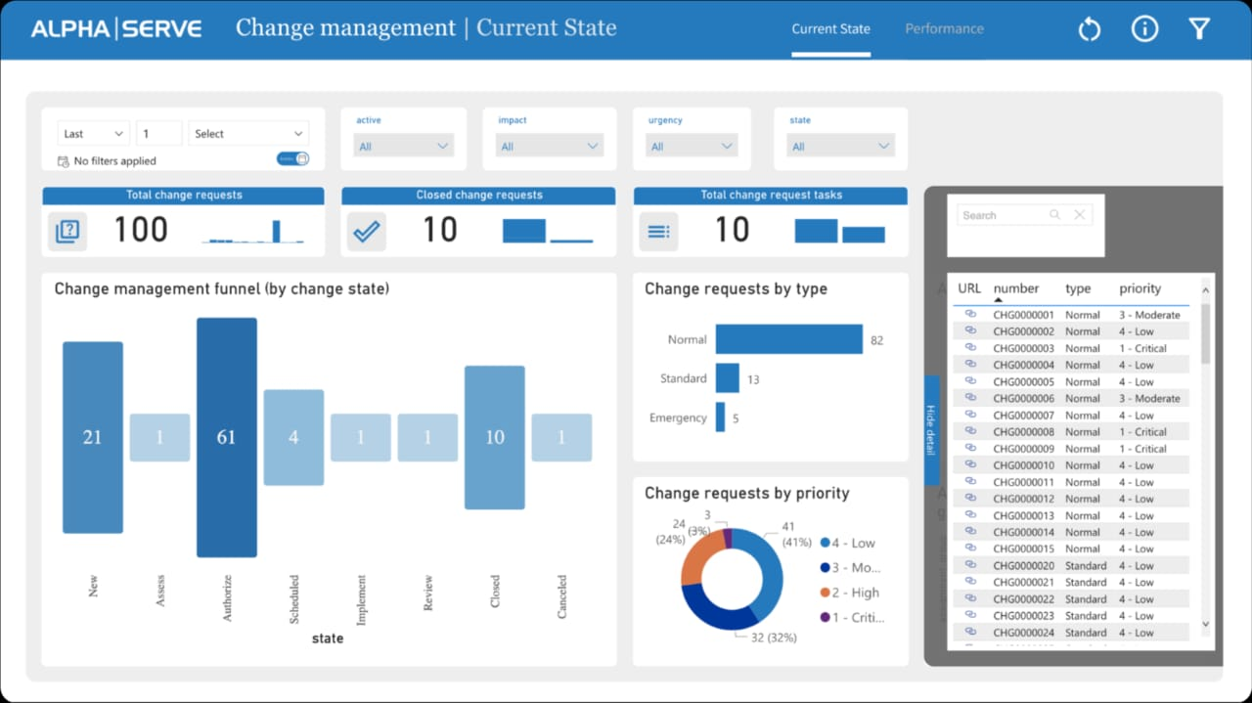
OUTPUT :

RESULT :
The Dashboard was successfully designed.

